**Znüni mal anderst…**

[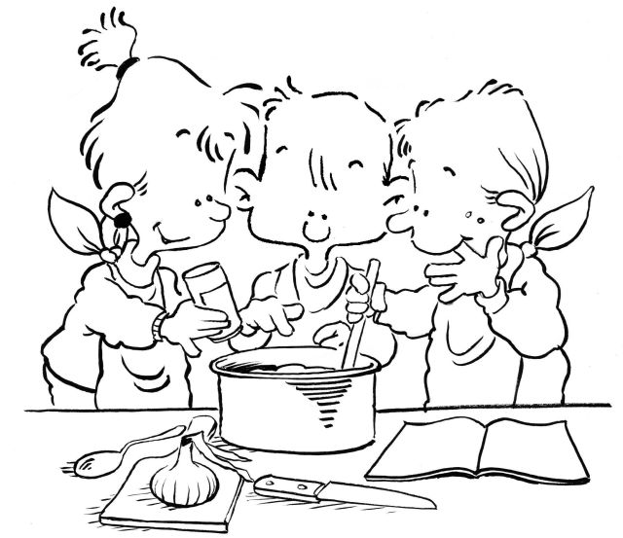](http://www.google.ch/url?sa=i&rct=j&q=&esrc=s&source=images&cd=&ved=0ahUKEwijiaCXsdrOAhWHvBQKHW5_AfwQjRwIBw&url=http://www.heinzwildi.ch/pics/kochen/kochen/kinder.jpeg.html&bvm=bv.129759880,d.ZGg&psig=AFQjCNHl3OVUVqzvhs7YTr5P7Nbmc-Zyyg&ust=1472139508938773)

|  |
| --- |
| **[[Schildkröten aus Kiwi Weintrauben Foodie Kinder Kids lecker gesund süß Obst:](https://meinheimvorteil.at/suse-obst-schildkroten/)](https://meinheimvorteil.at/suse-obst-schildkroten/)** [[Korb's kindergarten snacks:):](https://s-media-cache-ak0.pinimg.com/originals/d6/41/99/d64199ba7d4b325d1560c3eca2004893.jpg)](https://meinheimvorteil.at/suse-obst-schildkroten/) |
| [Love it !:](http://mommo-design.blogspot.it/2013/05/funny-food.html)  [Butterfly snack:](http://www.meetthedubiens.com/2014/03/a-fruity-butterfly-snack-for-kids.html) |
| **[[Melonen Spezial {so schmeckt der Sommer} – Frau Zuckerstein.:](http://frauzuckerstein.de/melonen-spezial-so-schmeckt-der-sommer/)](http://frauzuckerstein.de/melonen-spezial-so-schmeckt-der-sommer/)** [[Watermelon apple snack:](http://petitphant.blogspot.com/2013/06/for-your-picky-eater.html) [Melone am Stiel Das Auge isst mit! 27 Ideen für kreatives Kinder-Essen - www.ruhrpottKIDS.com:](http://ruhrpottkids.com/blogs/blog/das-auge-isst-mit/)](http://frauzuckerstein.de/melonen-spezial-so-schmeckt-der-sommer/) |
| **[[This could be done with lollies (if you want to make it a bit naughty). Great for birthday's at school or even special snack days...........:](http://www.buzzfeed.com/rachelysanders/easy-adorable-animal-snacks-to-make-with-kids)](http://www.buzzfeed.com/rachelysanders/easy-adorable-animal-snacks-to-make-with-kids)** |
| **[[Dit keer geen paas ei maar een kerst ei:](http://www.welke.nl/photo/angellove1968/Dit-keer-geen-paas-ei-maar-een-kerst-ei.1380206395)](http://www.welke.nl/photo/angellove1968/Dit-keer-geen-paas-ei-maar-een-kerst-ei.1380206395)**  [[Een ei hoort erbij! Al helemaal met het paasfeest... 8 leuke creatieve ei ideetjes! - Zelfmaak ideetjes:](http://www.zelfmaakideetjes.nl/feestdagen/een-ei-hoort-erbij-al-helemaal-met-het-paasfeest-8-leuke-creatieve-ei-ideetjes/26882/?utm_source=Pinterest&utm_medium=share-buttons&utm_campaign=image&att=26885)](http://www.welke.nl/photo/angellove1968/Dit-keer-geen-paas-ei-maar-een-kerst-ei.1380206395) |
| **[[Father who created cartoon-themed 'funky lunches' to get his children to eat fruit and veg creates his own party recipe book | Mail Online:](http://www.dailymail.co.uk/news/article-2212849/Father-created-cartoon-themed-funky-lunches-children-eat-fruit-veg-creates-party-recipe-book.html)](http://www.dailymail.co.uk/news/article-2212849/Father-created-cartoon-themed-funky-lunches-children-eat-fruit-veg-creates-party-recipe-book.html)** [[Babybel ladybirds - such a cute idea!!! Team up with our ladybird party range & polka range :):](http://www.flickr.com/photos/cmariani/3463302622/)](http://www.dailymail.co.uk/news/article-2212849/Father-created-cartoon-themed-funky-lunches-children-eat-fruit-veg-creates-party-recipe-book.html) |
| **[[Des sandwich au fromage frais, à essayer avec Kiri ! Chat vous plait ? :D #kiri #recette #Kids #food #recipe #sandwich #foodart #yummy #creamcheese #rigolo #miam:](http://www.twojediy.blogspot.com/search?updated-max=2015-01-15T00:04:00%2B01:00&max-results=5)](http://www.twojediy.blogspot.com/search?updated-max=2015-01-15T00:04:00%2B01:00&max-results=5)**  [[Father who created cartoon-themed 'funky lunches' to get his children to eat fruit and veg creates his own party recipe book | Mail Online:](http://www.dailymail.co.uk/news/article-2212849/Father-created-cartoon-themed-funky-lunches-children-eat-fruit-veg-creates-party-recipe-book.html)](http://www.twojediy.blogspot.com/search?updated-max=2015-01-15T00:04:00%2B01:00&max-results=5)  [[cutefoodmouse by kirstenreese, via Flickr:](http://www.meetthedubiens.com/category/cute-food/page/9)  [A Peary Cute Penguin:](http://www.meetthedubiens.com/2013/12/cute-snack-idea-a-peary-cute-penguin.html)](http://www.meetthedubiens.com/2013/12/cute-snack-idea-a-peary-cute-penguin.html)  **[[fun snacks:](http://www.littlefoodjunction.com/2013/03/womens-day.html#.UzTARfldV8E)](http://www.littlefoodjunction.com/2013/03/womens-day.html" \l ".UzTARfldV8E)** [[Banana pirates, how cute:](https://s-media-cache-ak0.pinimg.com/originals/80/77/44/807744c8696a88ef869cb6b1312ebb15.jpg)](http://www.littlefoodjunction.com/2013/03/womens-day.html" \l ".UzTARfldV8E)  **[[Lion snack:](http://www.meetthedubiens.com/2014/03/more-creative-food-plates.html)](http://www.meetthedubiens.com/2014/03/more-creative-food-plates.html)**  [[Sheep Fruit Snack:](http://kitchenfunwithmy3sons.blogspot.com/2014/04/sheep-fruit-snack.html)](http://www.meetthedubiens.com/2014/03/more-creative-food-plates.html) |